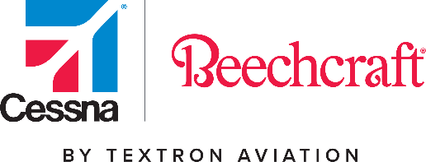

SUPPLIER QUALITY COMMUNICATIONS

Textron Aviation Inc. Material and Process Engineering has made the determination to eliminate the use of CMNP007 Type X sealant. The Type X sealant will be replaced by Type I or Type XIV material of the same class (B-2).

This document outlines the specification changes that will occur from this activity.
Action Required:

- Review the sealants being utilized at your facility and determine if this change will impact current work or any open request for quotes.
- Take the necessary steps to procure the authorized replacement material within the dates stated below.
- Report any issues this change may drive.

Implementation Actions:
- Textron Aviation will no longer use the CMNP007 It will become obsolete with no replacement, effective 4/1/2022.
- Textron Aviation has released CSNP035 Deviation – CSNP035-TXTAV-7
  - Applicable to all locations (including suppliers) (Text as follows):
  - Delete sections: 1.2.1.10 (Type X – Corrosion Inhibitive Sealant), 3.1.1.10 (MATERIALS) and 5.7.6.10 (Post-Application Requirements)
  - Delete reference to CMNP007 in section 2.1 (Cessna Specifications)
  - Delete all references to Type X throughout the specification.
- Either Type X, Type I or Type XIV may be used through the end of the first quarter of 2022.
- After 4/1/2022 all applications must be converted to Type I, Class B-2 or Type XIV, Class B-2.

Should you have any questions regarding this matter, please contact your Quality Engineering Representative.
Specification Update:
Elimination of CMNP007 Type X Sealant

